### **CS23333-Object Oriented Programming Using Java**

**NAME: B. ELUMALAI**

**ROLL NO: 230701084**

# **Lab-01-Java Architecture, Language Basics**

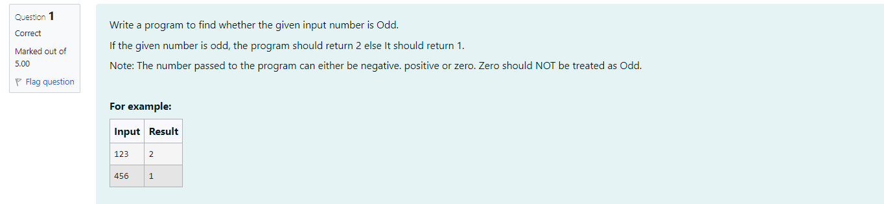

**CODE**

import java.util.Scanner;

public class Odd{

public static void main(String args[]){

Scanner s=new Scanner(System.in);

int n=s.nextInt();

if (n%2!=0){

System.out.print("2");

}

else{

System.out.print("1");

}

}

}

**OUPUT**

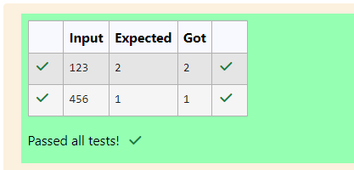

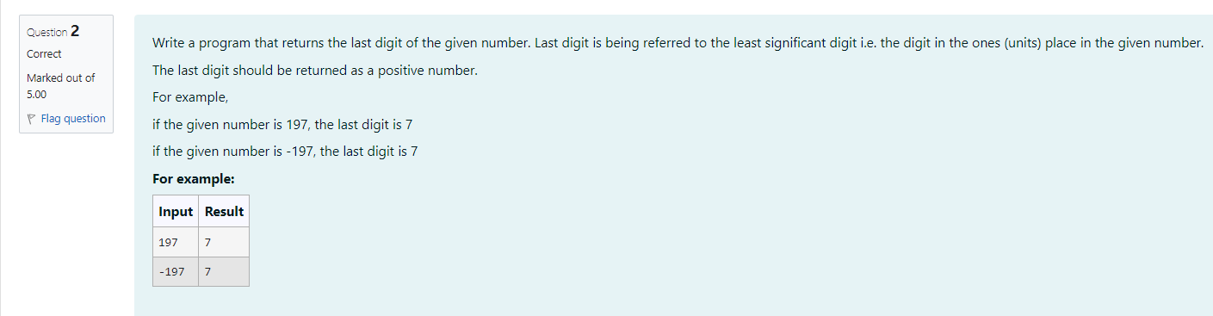

**CODE**

import java.util.Scanner;

public class Lastdigit{

public static void main(String args[]){

Scanner s=new Scanner(System.in);

int a=s.nextInt();

int abs-Math.abs(a);

System.out.print(abs%10);

}

}

**OUTPUT**

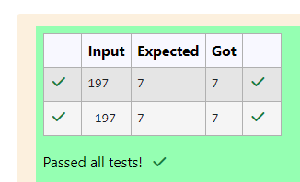

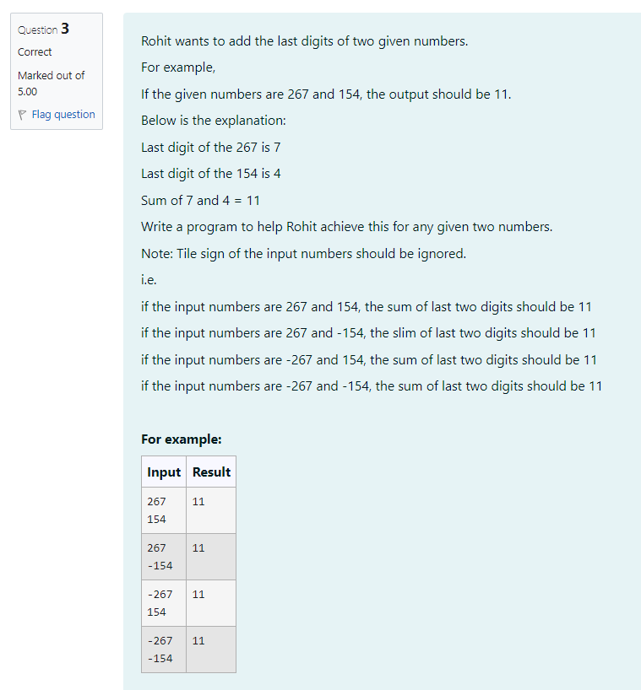

**CODE**

import java.util.Scanner;

public class Sum{

public static void main(String args[]) {

Scanner s=new Scanner(System.in);

int a=s.nextInt();

int b=s.nextInt();

int c=Math.abs(a);

int d=Math.abs(b);

System.out.print((c%10)+(%10));

}

}

**OUTPUT**

